



FPT UNDEFINED FLYING OBJECT
System Requirement Specification

Project Code: FUFO
Document Code: FUFO v1.0

Ha Noi, 1st May 2012
Record of change

*A - Added M - Modified D - Deleted
Effective Date | Changed Items | A*  M, D | Change Description | New Version
04-May-2012 | Detail purpose and scope. | A* | Create newly specification | V 0.1
09-May-2012 | Functional VP | A* | Create functional VP | V 0.2
22-May-2012 | Product functions | M | Describe more detail product function | V 0.3
2-June -2012 | System features | M | Describe feature of Quadrocopter | V 0.9
3-June-2012 | External Interface | M | Modify user interface of AOC | V 1.0

SIGNATURE PAGE

ORIGINATOR: Trần Thị Yến 19-May-2012
Member

REVIEWERS: Vũ Minh Phong 20-May-2012
Project Manager
Lý Khôi Nguyên 20-May-2012
Member
Vũ Đức Thắng 20-May-2012
Member

APPROVAL: Phạm Duy Hùng 22-May-2012
Introductor
TABLE OF CONTENTS
1 Introduction 5
1.1 Purpose 5
1.2 Scope 5
1.3 Definitions, Acronyms, and Abbreviations 6
1.4 References 7
2 Overall Description 8
2.1 Product perspective 8
2.2 Product functions 8
2.3 User characteristics 9
2.4 Operating Environment 9
2.5 Constraints 10
2.6 Assumptions and dependencies 11
3 System Features 12
3.1 AOC- Application on Computer 12
3.2 AOP- Application on Phone 12
3.3 FUFO- A Quadrocopter 12
4 External Interface Requirements 13
4.1 User Interfaces 13
4.2 Hardware Interfaces 15
4.3 Software Interfaces 17
5 Supporting Information 18

Introduction
The FUFO project develops commercialized Quadrocopter. It bases on Base on observation on the similar projects, a project this big may need four phases, each phase will be a relevant project to lead to the final product. This phase just focuses on the first evaluation phase.
This document describes a simple Quadrocopter which use Bluetooth & Internet protocol to communicate. After developing this phase, we can evaluation report and a Quadrocopter with basic functions that might meet customer needs.

Purpose
The SRS fully describes the external behavior of the application. This document includes two main parts:
Overall description includes such items such as: product perspectives, product functions, user characteristics, constraints, assumption and dependencies. This part provides background information to make the requirements be easier to understand.
Specification requirement provides detail information about FUFO’s system. This phase captures the complete software requirements for the system. And it gives us the most important information to project manager, designer, tester and maintainer

Scope
This project phase focuses on:
- Make a simple Quadrocopter.
- Use Bluetooth & Internet protocol to communicate.
- Evaluate the application of Android Phone & PC in controlling UAV.
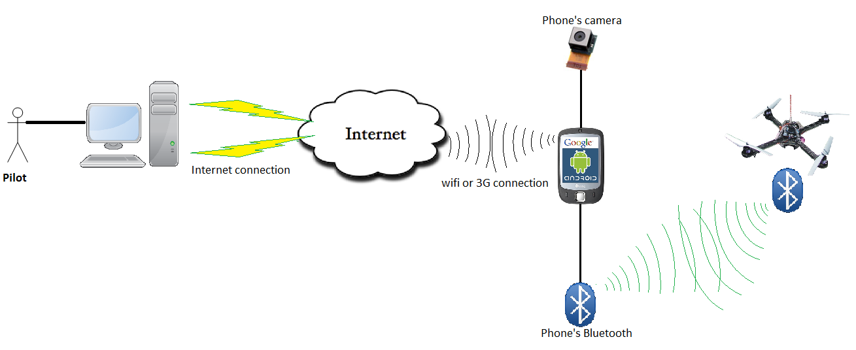

Definitions, Acronyms, and Abbreviations
Acronym | Definition | Note
PM | Project Manager
PTL | Project Technical Leader
TL | Team Leader
QA | Quality Assurance Officer
DV | Developer
SRS | Software Requirement Specification
ADD | Architecture Design Document
DDD | Detail Design Document
TP | Test Plan
TC | Test Case
SC | Source Code
AOP | Application on phone
AOC | Application on computer
FUFO | FPT University Flying Object | Controlled by AOC through AOP
PC | Personal Computer | Refer to any PC or laptop today

References
Document | Source | Note
Template Software Requirements Specification | FPT Software
Information from website: | http://www.microchip.com/

Overall Description

Product perspective
The overall product being specified in this document is the FPT University Flying Object. More importantly is the fact that this system contains an embedded system and controlling software requiring software.
This FUFO system is the result of the evaluation phase of a bigger FUFO project, which result is a Quadrocopter system that usable in security and observation purposes. The big FUFO project may need 3.5 years to finish, but this evaluation phase is only last 4 months.
Other results of this project are two study reports on the ability to hover of Quadrocopter and real-time video streaming over Internet.

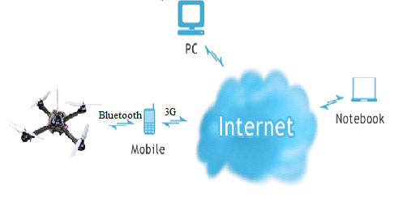

Product functions
The base aim of this phase is to make a basic Quadrocopter system that has ability to be controlled over Internet and Bluetooth via a Video Stream, as well as automatically balances itself while hovering. However, due to the shortage of time and money, the system will use an Android Smart Phone as a carrier of video streaming and commanding over Internet.
To be specific, the functions of the system is as the following:
- The Quadrocopter:
- Can be controlled via Bluetooth by an Android Smart Phone's application (AOP).
- Can send its sensors status to the Android Smart Phone via Bluetooth.
- Can automatically keep itself balance while hovering.
- Battery system should last at least 15 minutes when the Quadrocopter does not carry any weight.
- Can carry at least 500 grams and hover at least 30 meters high.
- The Android Application:
- Receives control command from PC.
- Sends control command to Quadrocopter.
- Send video and Sensor's status to PC.
- Easy to use, maintain and update.
- The PC Application:
- Receives video and Sensor’s statuses from Android Smart Phone and display them.
- Sends control command to Android Smart Phone.
- Easy to use and good looking.
- Easy to maintain and update.

User characteristics
There are two kind of user for this system, each has different characteristics:
- The development team:
- Fully understand the system.
- Focus on finding obstacles and undefined issues of the system to compare them with the advantages.
- Contains all the development team members.
- The evaluation user:
- Partially understand the system.
- Focus on finding the own experiences and feeling when uses FUFO system.
- May contain anyone who is interested in the project.

Operating Environment
There is more than one meaning for the term "Environment":
- The Nature environment for the Quadrocopter to hover in:
- Both out-door and in-door environment.
- Acceptable humidity.
- Acceptable temperature.
- The Technology environment for the Communication and software of FUFO system:
- Mobile 3G network
- 100 Mbs Wi-Fi network
- Any ADLS network available.
- Android 2.3 or higher.
- Windows XP and above.

Constraints
No | Description | Type
1 | Deliver one time and meet the requirement | Schedule
2 | All member of team must try one’s best, complete this work on time within 4 months | Staff
3 | The interface of Application on Phone will be friendly, easy to use and to be able to use after no more than 15 minutes. | Product
4 | Bluetooth should use version 4.0 | Product
5 | Accelerometer, Gyrocopter, Magnetometer, Barometric meter | Hardware
6 | Application on PC can run in many OS by JAVA virtual machine | Product

Assumptions and dependencies
No | Description | Type
1 | Install on Computer ( Laptop or PC) | Infrastructure
2 | Product can connect to Internet and PC. | Infrastructure
3 | Project team members are available as needed to complete project tasks and objectives. | Member

System Features

AOC- Application on Computer
3.1.1 Description and Priority
The software must display the current altitude and the inclination of FUFO frame. Beside user can control the FUFO by 8 buttons: “right-left”, “frontward-backward”, “up-down”, “left-rotate – right-rotate” and showing video real-time

3.1.2 Functional Requirements
REQ-1: The software can show altitude of FUFO belongs to meters (0~600m)
REQ-2: The inclination belongs to degree (- 90º + 90º)
REQ-3: The control system must meet to keyboard.

AOP- Application on Phone
3.2.1 Description and Priority
The software must record video from camera of smart phone, and receive information: current altitude, inclination from FUFO frame.
Beside smart phone can be used a remote control. It includes control system have 8 buttons: “right-left”, “frontward-backward”, “up-down”, “left-rotate”, “ right-rotate” and showing video real-time

3.2.2 Functional Requirements
REQ-1: The software receive and send information of FUFO: the altitude, inclination
REQ-2: The smart phone is intermediary object can create a connection between FUFO frame and PC
REQ-3: Used remote control

FUFO- A Quadrocopter
3.2.1 Description and Priority
This Quadrocopter is a multicopter lifted and propelled by four motors. The motors are mounted on the same plane, forming a square

3.2.2 Functional Requirements
REQ-1: Quadrocopter must keep balance in the middle of the air
REQ-2: Quadrocopter can maintain a reasonable specified altitude

External Interface Requirements

User Interfaces

4.1.1 User Interface on circuit board
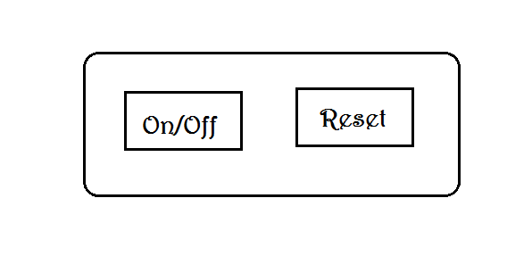
With FUFO system, user can control by 2 buttons: On/Off and Reset
User Interface on computer

Application on the computer includes:
Video from smart phone attach on FUFO frame
Remote control
The altitude of FUFO frame compares with the ground
The inclination of FUFO frame compares with the sea level
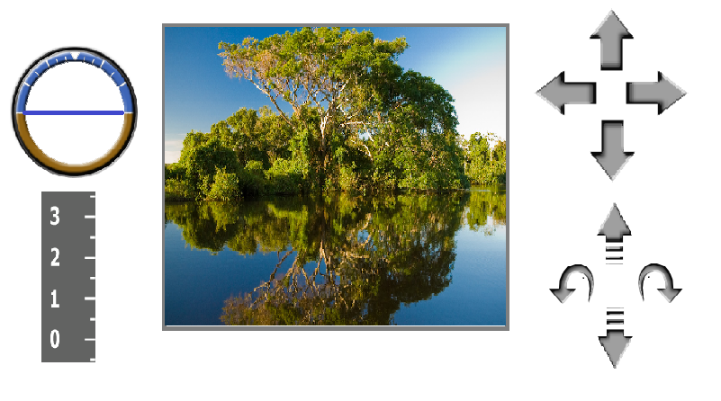
User Interface on smart phone

Application set up on the smartphone includes 2 tabs.
When choosing tab1 “SETTING”, user can select connection methods: Bluetooth or Internet Protocol.

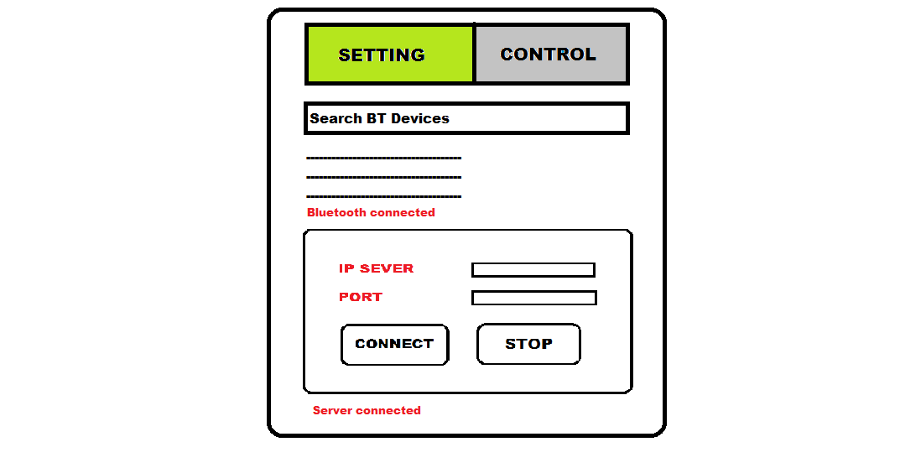
When choosing tab2 “CONTROL”, user can control FUFO by arrows such as “right”, “left”, “frontward”, “backward” and “up”, “down”, “left-rotate”, “and right-rotate”

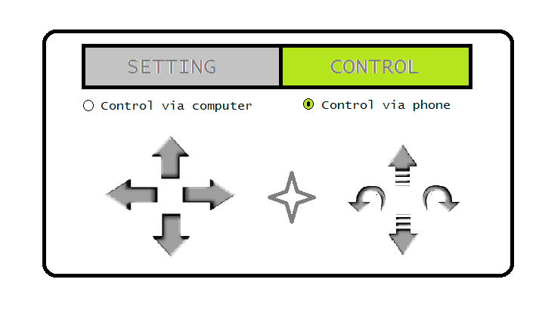

Hardware Interfaces
4.2.1 Hardware Interface on FUFO
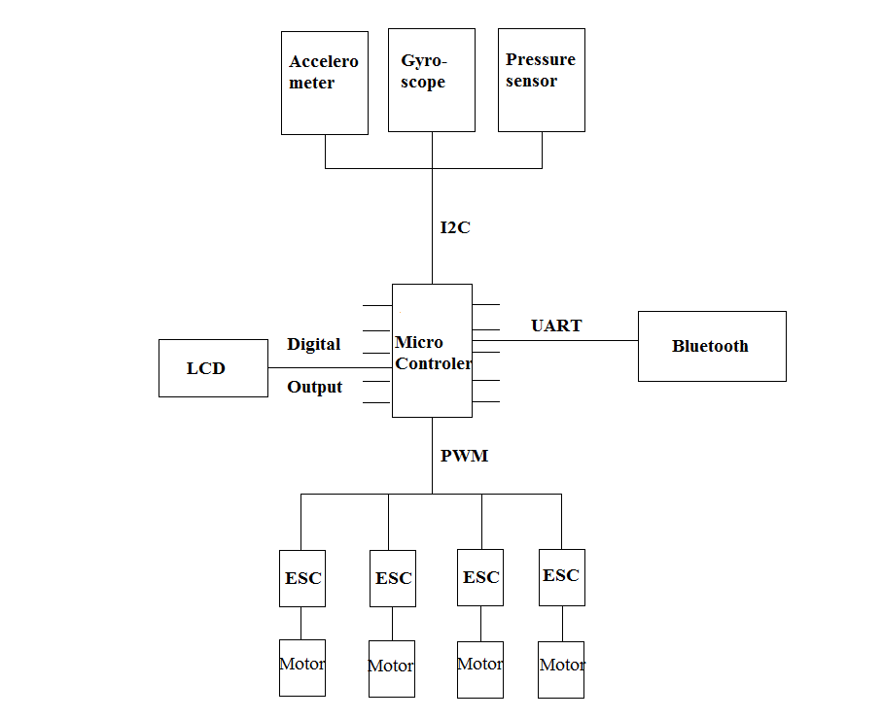

4.2.2 Hardware interface on Mobile phone
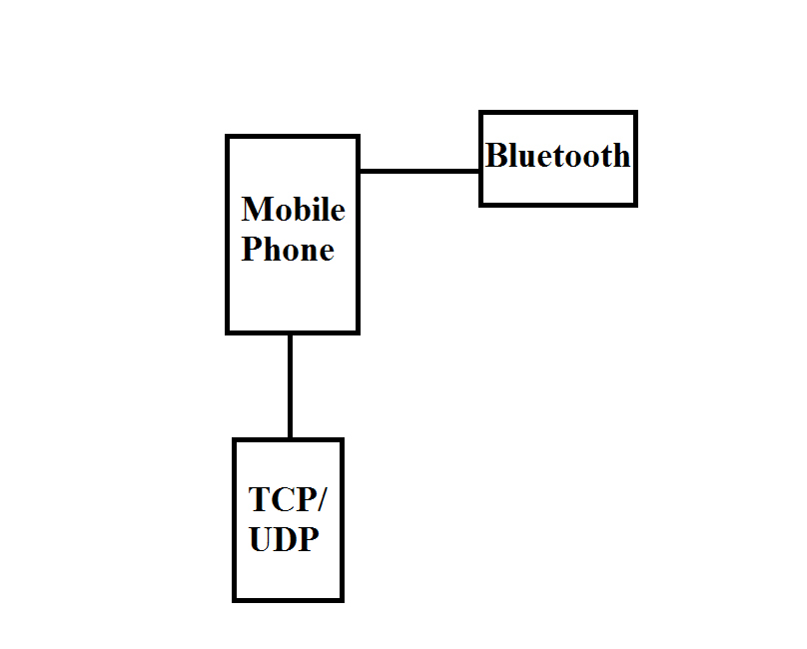

Software Interfaces
In our system, we use 2 applications on computer called AOC and Phone called AOP. Moreover we embedded a firmware on FUFO.
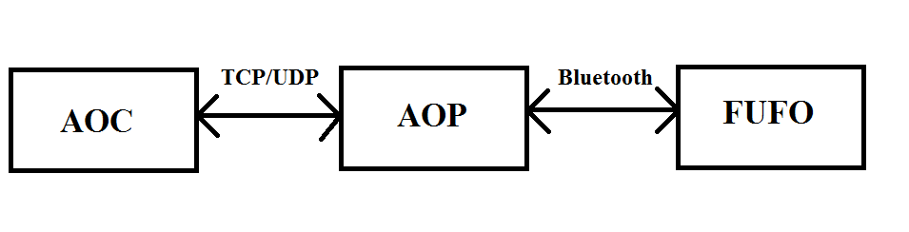
The TCP/UPD can use 3G or Wi-Fi to communicate AOC and AOP together.

Supporting Information
N/A

